## AQ1.7

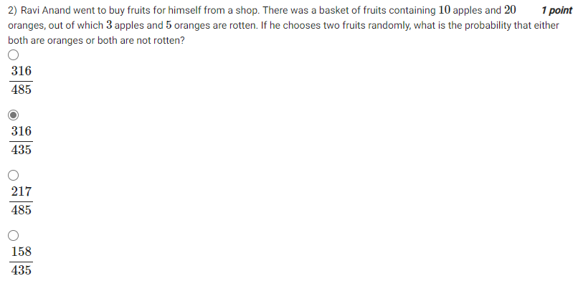

## AQ1.8

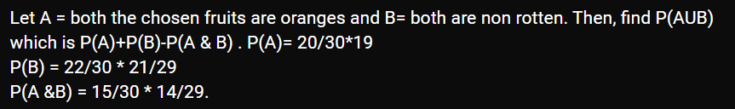

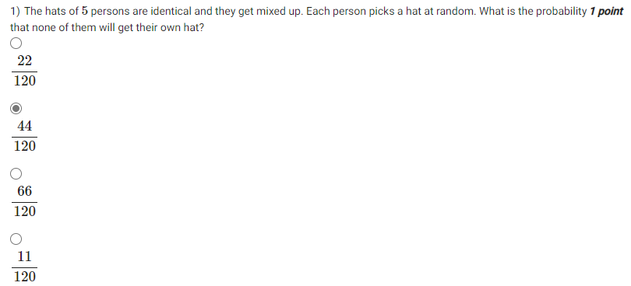

## AQ1.10

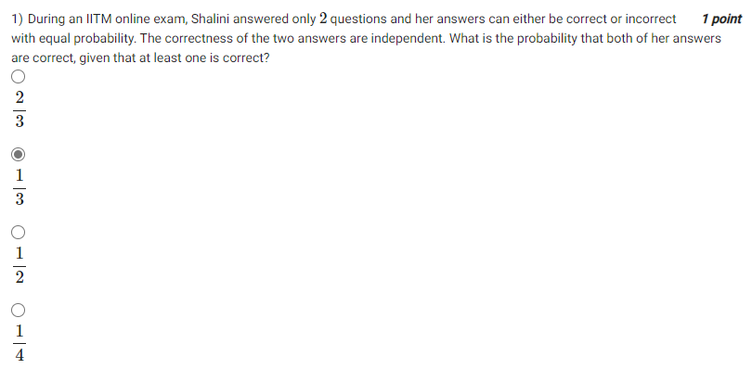

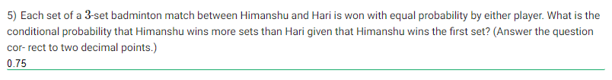

## AQ1.15

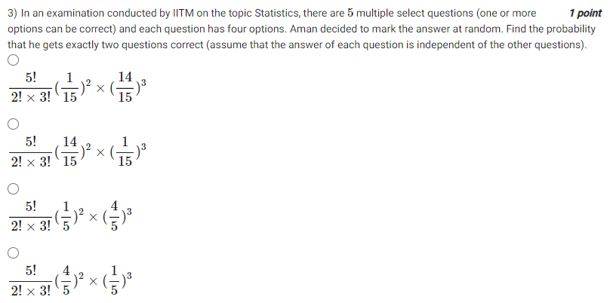

Hint: one or more options removes the possibility of all options unselected, so number of options are (16-1)=15.

## Practice1

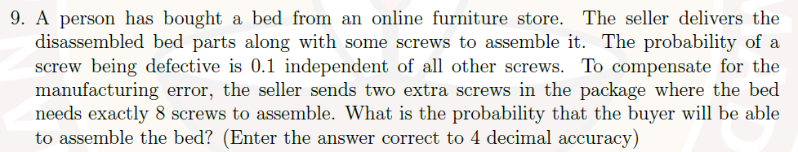

## Graded1

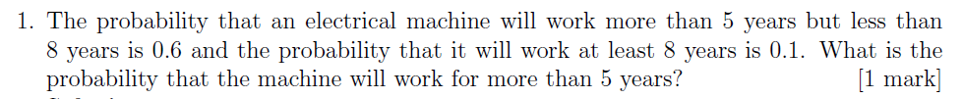

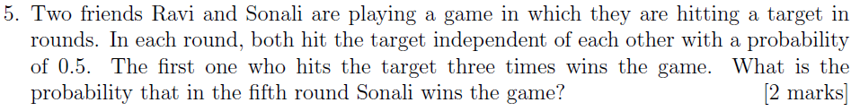

Hint: Sonali not achieving target doesn’t mean Ravi achieves target.

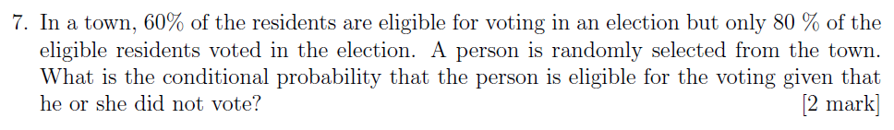

Hint: If person is not eligible, he cannot vote.



Hint: While finding probability of 2 completing task, multiply probability of the third person NOT completing also.

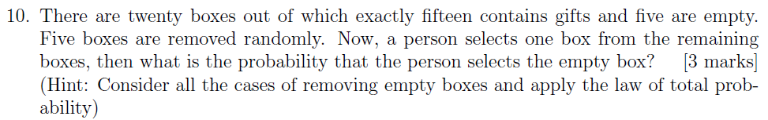

## Week2 Tutorial 3

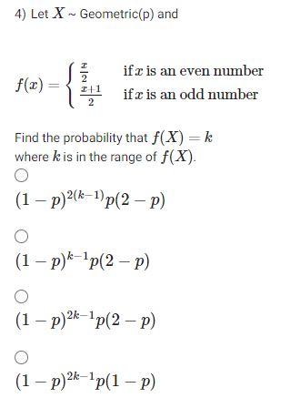

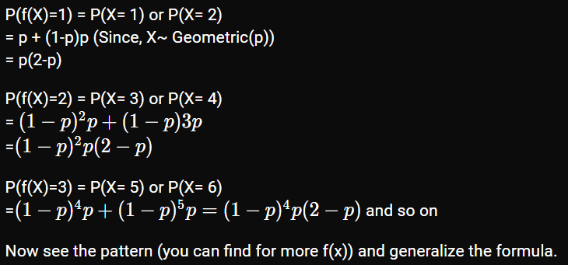

## Graded2

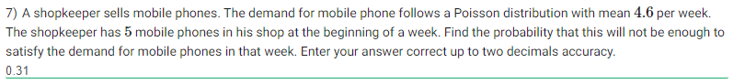

Hint: Find probability that the demand exceeds 5, P(X > 5) = 1 – P(X<=5)



Hint: Negative binomial. N = 8, p = 0.6, r = 5. Apply this to ${N-1}_{c_{r-1}}p^{r}{\left(1-p\right)}^{N-r}$

## Week3-Tutorial1



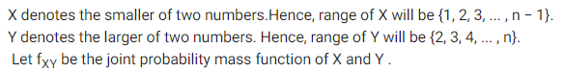

If Y can take values between 1 and 10 (say), X can take 1 less value. Both are uniform distributions. Thus, P(Y) = 1/n and P(X) = 1/n-1. These are independent and hence probability is 1/n*(n-1). Since the X or Y can occur first, the result must be multiplied by 2. Thus, final answer is

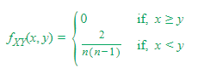

## Practice3

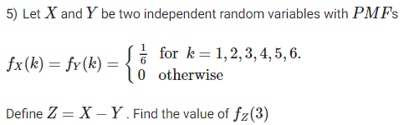

In such problems, represent distribution of z in terms of X and Y.

In this case, Y = X – Z. Thus, fz(3) = fxy(x=4, y=1) + fxy(x=5, y=2) + fxy(x=6, y=3)

## Week4-Tutorial2

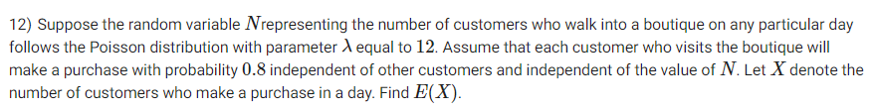

N is Poisson distribution Poisson(12). X|N = Binomial(n, 0.8). Thus, X is Poisson(0.8*12) = Poisson(9.6). Expectation of X is hence 9.6 (equals λ)

This is because Poisson superimposed with Binomial gives a Poisson with lambda multiplied by the Binomial probability.

## Practice4



X is Poisson(21)

Y is Poisson(21 * 2/3) = Poisson(14) {Refer to the above problem.}

E[X + Y] = E[X] + E[Y] = 21 + 14 = 35

## Graded4



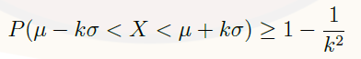

Here kσ = 4.

So, RHS is 1-1/8 = 7/8

## AQ5.5

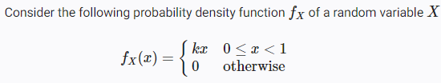



First, integrate kx from 0 to 1 and equate to 1, to obtain the value of k to be 2. Thus,

Now, F(0.5) = P(X < 0.5) = integral of 2x from 0 to 0.5. This results in 0.25.

## AQ5.7

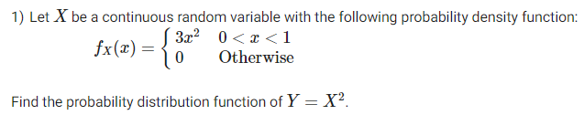

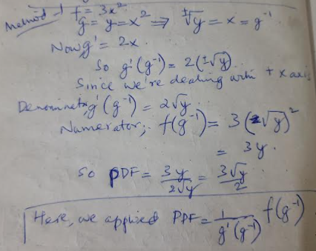

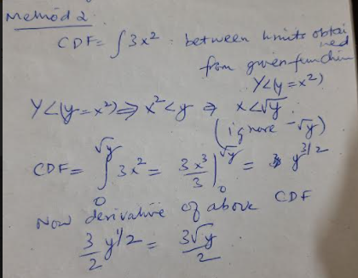





## Week5-Tutorial2



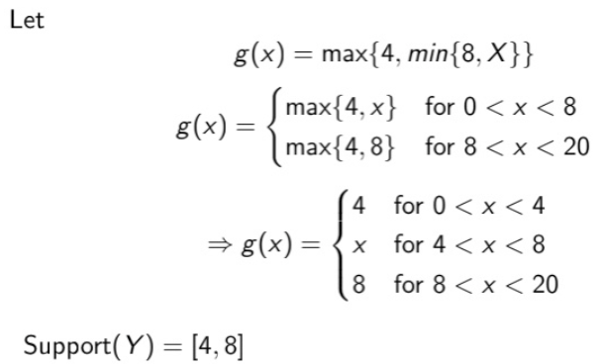

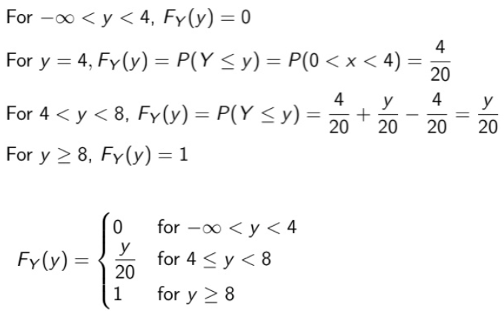



Use formula Variance = E[X^2] - (Mean)^2

Variance and Mean is 25 and 10 respectively. Find E[X^2] and multiply by 2.

## Graded5

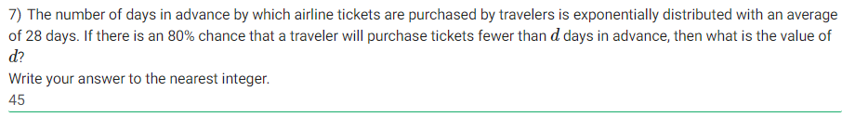

Here, mean is 28 days. This implies 1/λ = 28 days. Now, use the exponential formula like below

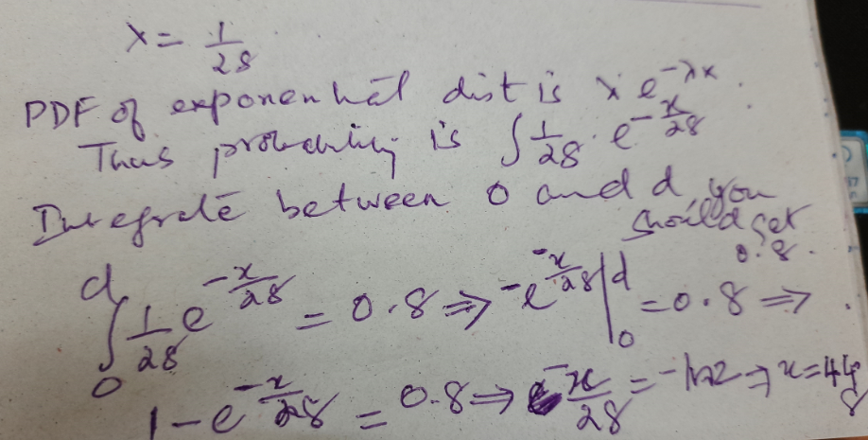

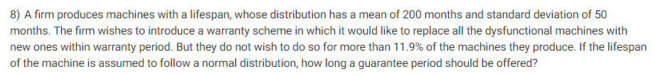

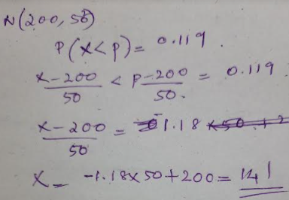

## Week6

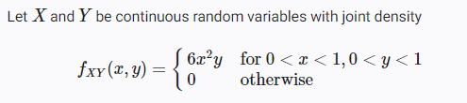



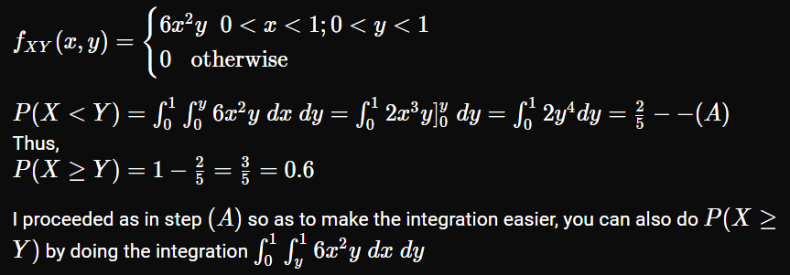

## Week6 – Tutorial3

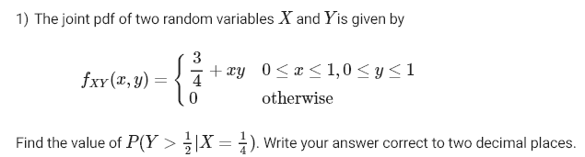

Such problems can be solved in 3 steps.

1. Fy|x = fxy/fx. Compute fx (marginal X) by integrating over Y (in this case 0-1). Then divide the specified fxy (in this case ¾+xy) by fx.
2. Now, substitute x with ¼ in the resulting expression.
3. Now, find P(Y > ½|X=¼) by integrating above expression between ½ and 1

## Graded6

## 

## 

Since Var(2Z) = 4Var(Z) and Var(3Z) = 9Var(Z), we can write

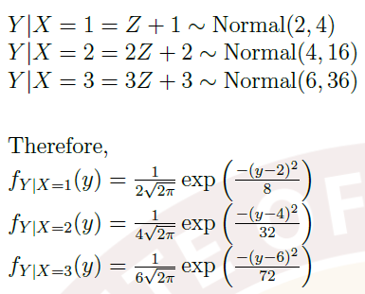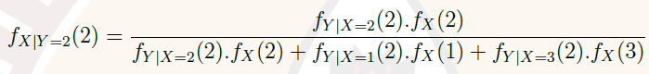

## AQ8.4

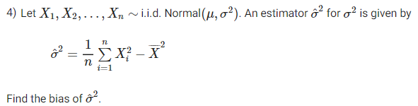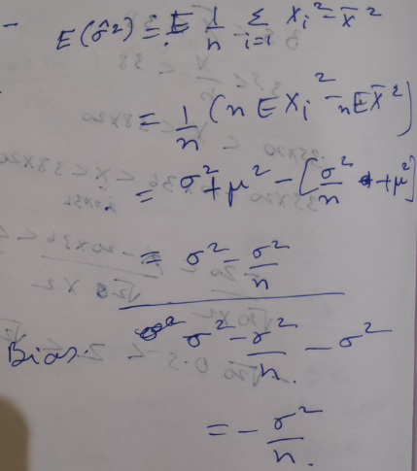

## Solve with us-8

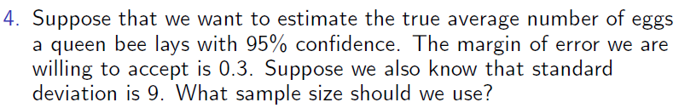

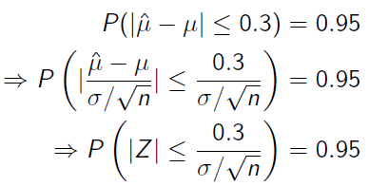

Now, 2Fz(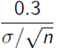) – 1 = 0.95. This implies Fz()= 1.95/2 = 0.975 and hence,

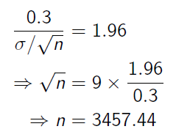

## Practice8

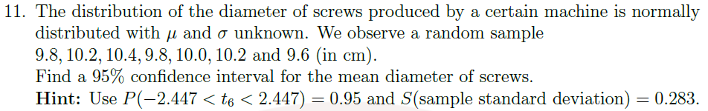

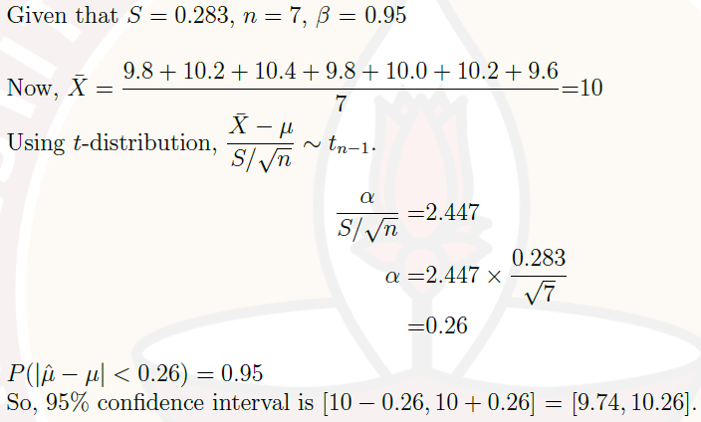

## AQ9.5 Q.3





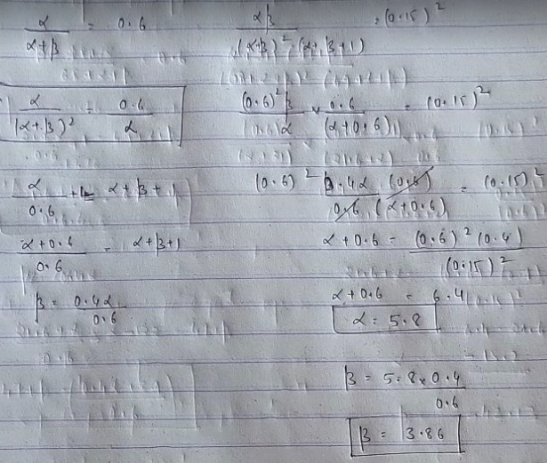

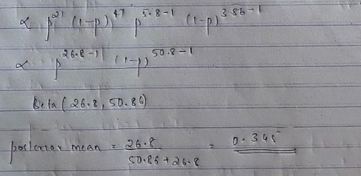

## AQ9.5 Q.4



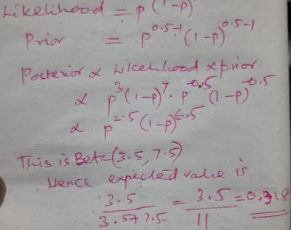

## AQ9.5 Q.5



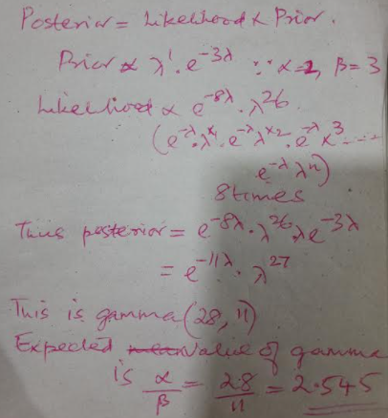

## Practice9

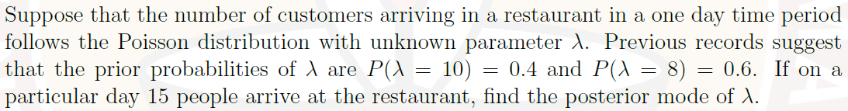

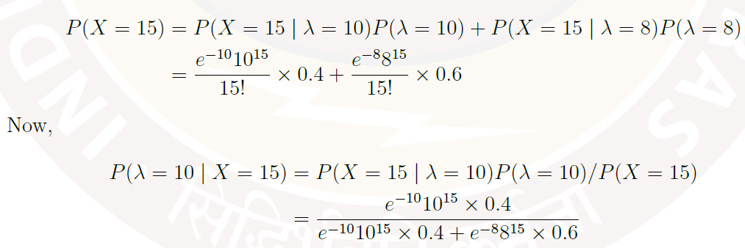

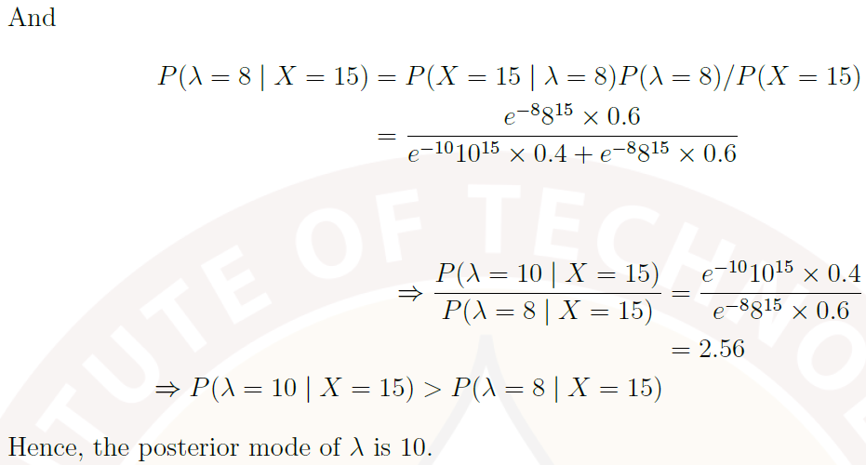

## AQ10.6

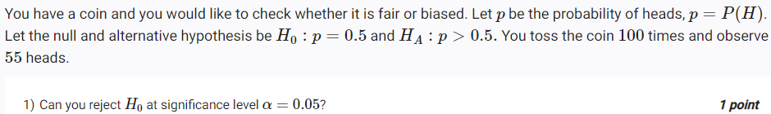

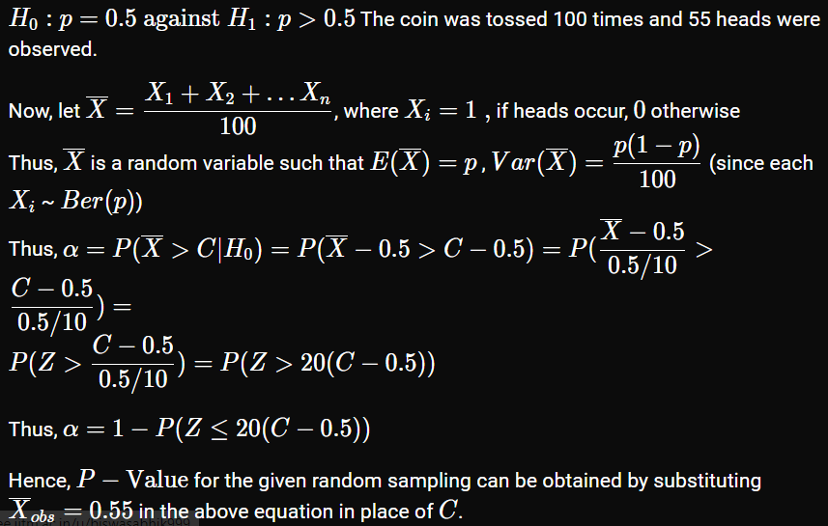



## Others

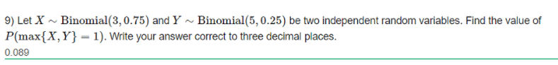

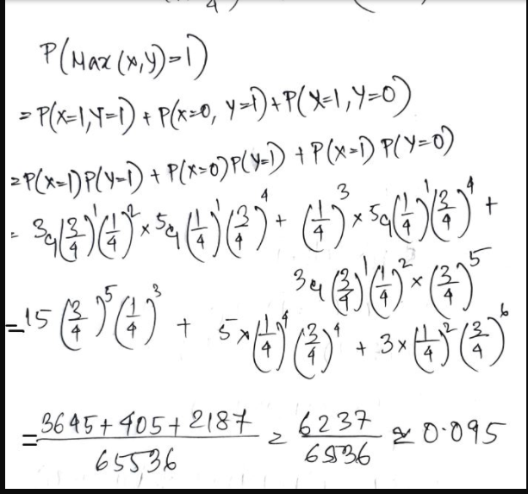

<https://discourse.onlinedegree.iitm.ac.in/t/quiz-1-june-20-question-9/10370/4?u=anand>

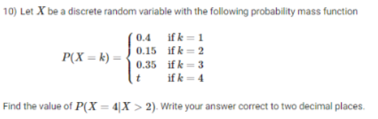

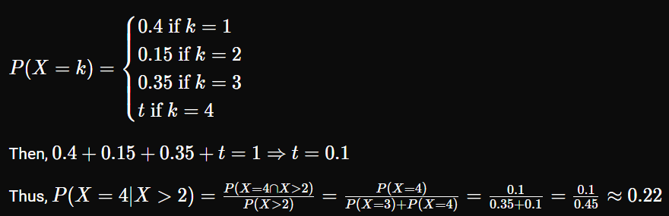

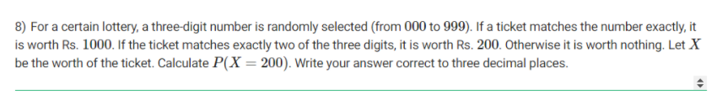

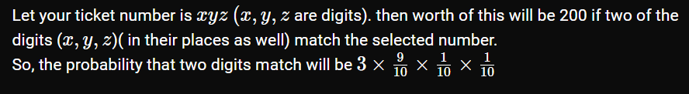

This can also be solved as a binomial problem. 3C2*(1/10)^2*(9/10)

<https://discourse.onlinedegree.iitm.ac.in/t/refresher-week-q8/9979/5?u=anand>

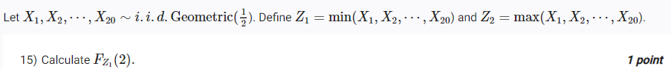



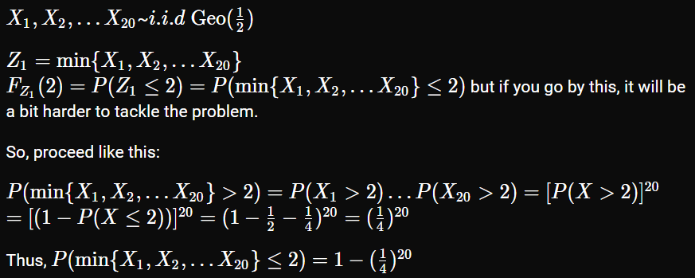

<https://discourse.onlinedegree.iitm.ac.in/t/refresher-week-q-15-and-q16/9923/4?u=anand>